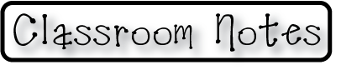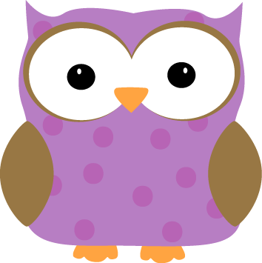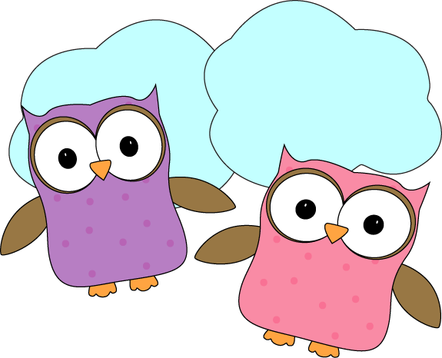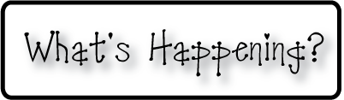

* **Please make sure your child has a water bottle**

**that can be refilled throughout the day**

* **Don’t forget your homework folders every day!**
* **Check out our classroom website!**
  + **christynseacoastcharter.weebly.com**
* **Next Week’s Star: Richard!**

**Next week-**

* Now that reading assessments have (finally!) been completed, we will rearrange some of our reading groups and really get started with various lessons during Guided Reading time. We’ve had a great introduction to working in smaller groups and now we will really get into the specific lessons to help us get even better at reading and writing!
* We are getting more familiar with ten frames and will get more practice with them next week. This will help us get better with adding to 10 and will set us up for practicing twenty frames and learn more with adding to 20.
* We’d like to discuss the different continents next week and learn what and where they are.

**This week-**

* We talked about the 5 oceans of the world: Atlantic, Pacific, Indian, Arctic, and Southern. We learned a song to help us remember them and have been practicing creating motions to help us remember the song!
* We also discussed the Equator, and Northern and Southern Hemispheres. We were able to tie this in with last week’s work on compass roses and discussed how the ***EQUATOR*** splits the world into two ***EQUAL*** parts. And also that the ***HEMISPHERES*** are ***HALF SPHERES***.
* We made lists of –at and –an words in our whole group lesson for reading groups. These lists are posted in the classroom to help us with writing and reading words we are familiar with.

**Christyn’s First Grade**

**Weekly Newsletter**

September 29-October 3

