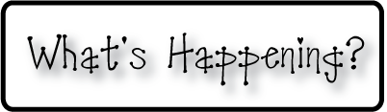

* **Please make sure your child has a water bottle**

**that can be refilled throughout the day**

* **Don’t forget your homework folders every day!**
* **Check out our classroom website!**
  + **christynseacoastcharter.weebly.com**
* **Next Week’s Star: Chloe!**

**Next week-**

* We will continue reading groups and working on spelling and sight words.
* A new list of words will go home next week for homework on Monday.
* We will continue our study of graphs and practice making different graphs of our own. We’re doing really well remembering how to make and read tally marks, and so next week we will look at tallies on a graph and discuss what kinds of information we can read off of the graphs.
* We will continue our study of the Earth’s land and water masses, and talk about the names of the different oceans next week.

**This week-**

* We finished our Otis paintings! They. Are. WONDERFUL! I hope you all have a chance to come and see them outside of the classroom, but if not I am going to post pictures on our website (christynseacoastcharter.weebly.com) of the kids working on them and the final products. I was so proud of how well the kids sat and focused and you can see it in their final products
* We also started homework for the first time, and I’ve received a lot of positive responses from parents and kids, which is so great!
* Reading groups are off to a great start and the kids are adjusting well to the new part of our day.
* We talked about North, South, East, West and designed our own Compass Roses! We also discussed ways to help us remember the order of N,E,S,W using clues like “Never Eat Soggy Waffles”!

**Christyn’s First Grade**

**Weekly Newsletter**

September 22-26, 2014

