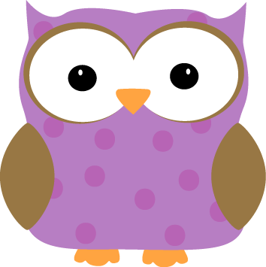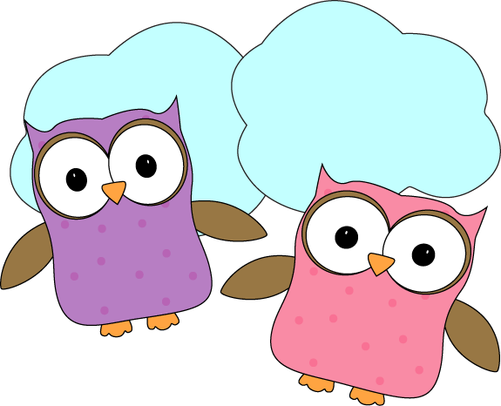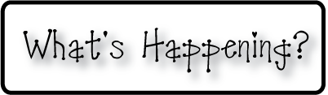

**Please make sure your child has a water bottle that**

**can be refilled throughout the day**

**Don’t forget your homework folders every day!**

**Next Week’s Star: Clara!**

**Next week-**

* Reading groups are beginning this week!
* We will talk about the oceans and continents of the world, and design our own compass roses.
* To finish off our Loren Long unit, we are making crayon resist paintings that we will hang outside our classroom and will send pictures to Loren Long as a final “Thank you!” for coming to our classroom! They’re off to a GREAT start!
* In math we will continue to review graph making, and addition skills.
* Homework will go home next week. But don’t worry, we’re going to start off easy to work our way into it.

**This week-**

* We completed our discussions and studies in regards to where we live (Earth, North America, The United States, New Hampshire, and our home towns)
* This week we started to really practice filling each other’s buckets (ask your kids what this means, but we’re working to make sure that we’re doing things that make people feel better and not doing or saying things that will hurt feelings)
* Reading assessments are just about complete and reading groups will get underway next week!
* Curriculum night was a great success, and Andrea and I got some great ideas for places we could look into for field trips! Thank you to everyone who came!
* Our classroom website is now up and running!

**Christyn’s First Grade**

**Weekly Newsletter**

September 15-19, 2014

