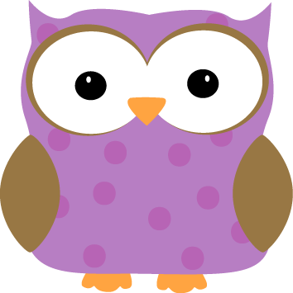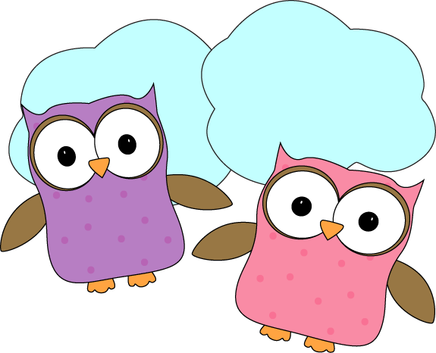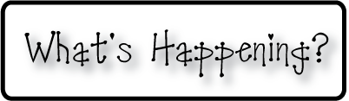

* **Conferences NEXT week: Oct 14,15,16, and half**

**day Friday, Oct 17 for other class’ conferences**

* **Don’t forget your homework folders every day!**
* **Check out our classroom website!**
  + **christynseacoastcharter.weebly.com**
* **Next Week’s Star:Riley!**

**Next week-**

* We will continue to talk about the oceans, and continents of the world to really help us remember all of the names. We will also learn the names of a few types of land forms to close out our Social Studies unit on Map Skills.
* Please start saving paper towel rolls and toilet paper rolls! We will be starting our space unit either next week or the week after and will need them for a special constellation project we will be doing!
* We will discuss a moon project we will be starting the following week (Oct 20-24).
* We’ll receive a new spelling and sight word list to practice.
* We are starting Personal Narrative writing pieces and will take what we started this week and work to “spice” them up and make them really detailed and exciting to read!

**This week-**

* We talked about the **–ap** word family and made a list of words ending in **–ap**.
* We began talking about the different continents in the world and played a team game to go over facts about the different continents and help us remember the names of the continents. There are 7, can you and your student name them all??
* Homework is off to a great start in 1st grade. For now, we are continuing to have the same math practice menu, and reading log with new sight words/spelling each week. Soon we will start receiving math pages to practice specific topics we are learning about in class.
* We began our first Personal Narrative story and discussed that stories have a beginning, middle and end. We’re off to a great start!

**Christyn’s First Grade**

**Weekly Newsletter**

October 6-10

