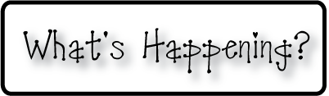

* **Nov 11- No School- Veteran’s Day**
* **Nov 21- Noon Dismissal**
* **Nov 26-28 No School- Thanksgiving Break**
* **Don’t forget homework folders EVERY day so work**

**can go home safely!**

* **Look for your child at christynseacoastcharter.weebly.com**
* **Next Week’s Star:Gabrielle!**

**Next week-**

* We will continue our unit on the moon and will keep building our Moon Phase Calendar.
* Our moon mobiles will get finished next week and we will see them hung up outside of our classroom for others to see!
* We will continue our work on India, and begin a 2 week project where we will create our own version of a Pookalam (an Indian art form where flowers are arranged in designs to create beautiful floor mats), and Rangoli (a traditional Indian art floor painting).
* We will get our Passports next week too, as we begin our journey around Asia!

**This week-**

* We began our unit on India! We have started a mini book during our Reader’s Workshop Groups to learn some interesting facts about India.
* We are continuing to learn about the moon. We’re getting very good at remembering the names of the different phases, and will continue to build our classroom moon phase calendar.
* We also read a few books this week talking about the other planets in our solar system!
* We’re taking a little break from building numbers to 20 and starting to practice counting down from higher numbers this week. We played games helping us to remember some of those trickier numbers in the teens that sometimes get us stuck.

**Christyn’s First Grade**

**Weekly Newsletter**

October 27-31

