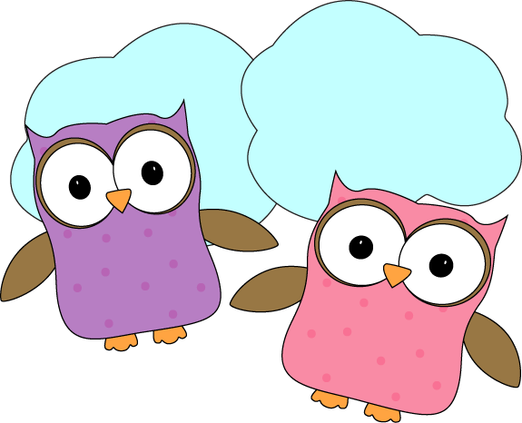

**Christyn’s First Grade**

**Weekly (oops! This one’s a monthly!)**

**Newsletter**

November 17-December 5

**Next week-**

* We will finish our Personal Narrative stories early next week and have them published for viewing in the classroom! We will discuss the importance of taking extra special care of these books as they will be available for all of us to read and enjoy. We want to be sure that our hard work is taken care of here so it will be in great condition when it goes home too. It will be great for families to discuss this with their students as well.
* We will continue our unit on Geometry and working with shapes in Math.
* We will finish our Pookala art that we began this week, and move on to a new art project as we study the Banyan tree next week! Banyan trees are a very important part of Indian culture and we will learn just how important it is next week!
* Finally, we will bring our Space unit to a close next week and the following week after as we get ready to move on to our light and sound waves unit.

**December 11- Winter Concert at 6pm**

**December 19- Half Day- Noon Dismissal**  
**December 24-January 2- Holiday Break- No School**

* Don’t forget warm jackets, snowpants, boots, gloves/mittens,

and hats **every day**! It’s getting cold and you need them for snow!

* + Indoor shoes and slippers **(that stay on easy)** can stay at school
* Next Week’s Star: **Keyn**!

**This month-**

* Wow, the time has flown! How did we make it into December already?! In the last week before Thanksgiving break and this past week after, we have done a lot of work to FINALLY finish our Indian Rangoli artwork! The kids have done an AMAZING job with those and I couldn’t be more proud. I’m happy to report that they seem to be just as proud, and it really helped to get to present them at our Whole School Meeting today and get the “ooh”s and “ahh”s from everyone else too!
* We practiced some of our math addition facts before vacation, and this week we have also begun Geometry! This has tied in very well with our Rangoli artwork as we talk about shapes and the attributes of each, in addition to ways to make some shapes using other shapes.

