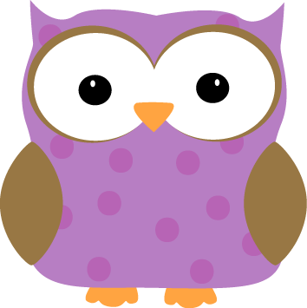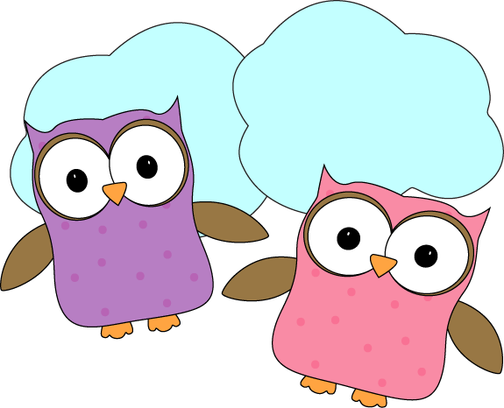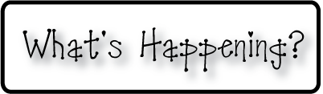

**Next week-**

* We will finish up our Moon Calendar as we complete our final portion of the past month’s phases! It’s been so fun to watch our calendar grow and get to see just how the moon changes over the course of the month. A photo will go up on our website next week so parents and families can see our completed work.
* We will finish our Indian Rangoli work next week and hope to begin our next project as we study India, and create our Pookala art! This is a form of artwork in which flowers are used to create beautiful floor mats, however we will create ours with a much longer lasting tissue paper effect.
* We’re continuing our Personal Narrative stories that we began this week, and will work on our first full draft. Some of us started this week but we hope by the end of next week that most of our stories will be near completion of our first full rough draft and moving forward towards the publishing portion of this project! We can’t wait to share our stories with our families!
* **Nov 21- Noon Dismissal**
* **Nov 26-28- No School- Thanksgiving Break**
* **December 5th**- We will present at Whole School Meeting!
* Don’t forget warm jackets **every day**! It’s getting cold!
  + Indoor shoes and slippers **(that stay on easy)** are welcome to leave at school!
* Look for your child at **christynseacoastcharter.weebly.com**
* Next Week’s Star:Ethan!

**This week-**

* This has been a short, yet eventful week with our day off on Tuesday to rest and reflect on our brave veterans and everything that they’ve done for our freedoms.
* Thursday we had a fantastic field trip to the McAuliffe-Shepard Discovery Center in Concord! We learned so much about space and got to see a show about our night sky! It was amazing getting to shoot through space and see far off galaxies, constellations, planets and the moon! (Photos to come!)
* We’ve started to work on our final Rangoli artwork, and look forward to presenting that at our Whole School Meeting on **December 5th**!
* We began our Personal Narrative work this week, and I’ve been SO proud of the work our class has been accomplishing! We look forward to continuing next week.

**Christyn’s First Grade**

**Weekly Newsletter**

November 10-14

