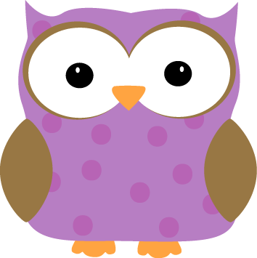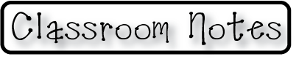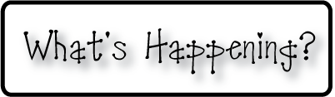man

**Next week-**

* We will have another Math Fluency Test on **Monday**.
* We will learn about how animals communicate with each other
* We will learn about how different animals have different attributes that help them to survive better than others in the wild
* We will continue working with 3D shapes in Math
* We will review what we have learned in math over the course of the year in preparation for our upcoming end of the year math assessments.
* We will continue our regular reading groups in preparation for our upcoming end of the year reading and sight word assessments.

**-Needed in our class-**

* Black construction paper (standard sized and large)

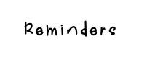

**This week-**

* Wow, what a busy two weeks back to school! This week, we started learning about “organisms” and talked about what makes something living or non-living. We got a chance to observe mealworms in class too, and compare how mealworms respond to things like food, water, and our touch, compared with how our pet rocks that we made respond.
* We also began talking about parent and baby animals and the differences and similarities, including what we call each.
* In writing, we created paintings of Mo Willem’s Pigeon, and made them all dirty, just like in the book Pigeon Needs a Bath. After we finished our paintings, we wrote our own stories about how the pigeon got so dirty in the first place!
* We have discussed 3D shapes and what the “face” of a 3D shape is. We compared faces of different shapes, and created a book of 3D shapes!

**Christyn’s First Grade**

**Weekly**

**Newsletter**

May 4th-15th

* **May 25- Memorial Day- NO SCHOOL**
* **End of the year math and reading assessments will begin**

**the week of May 26th**

* **June 4- 1st and 2nd Grade Spring Concert- Swasey Gym at 6:30. 1st and 2nd Graders should arrive at the Swasey Gym by 6:20**
* Next Week’s Star: **Amelia**!