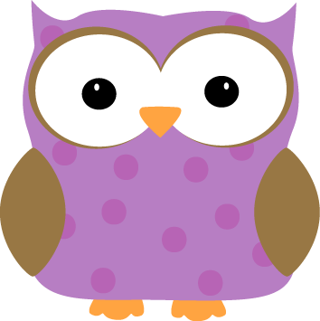man

**Next week-**

* We will have our LAST Math Fluency test on **Monday**!
* We will finish work on our classroom book to present at Whole School Meeting on Friday, June 5th (8:45am! All are welcome!)
* We hope to finish our end of the year assessments
* We will continue learning about plants and animals. We will discuss the different parts of an insect’s body, as well as a flower. We will also talk about the different uses of various parts of a plant an animal “body”.

***WEEKEND CHALLENGE!!***

While many of us are able to tie our shoes already, there are some who need practice. Please work this weekend on tying sneakers as this is important for you to be able to do on your own next year in 2nd grade ☺



**This week-**

* We participated in the Color Run! The kids did a great job collecting money to help save SCS, and then earning that money by doing over 100 laps all together!

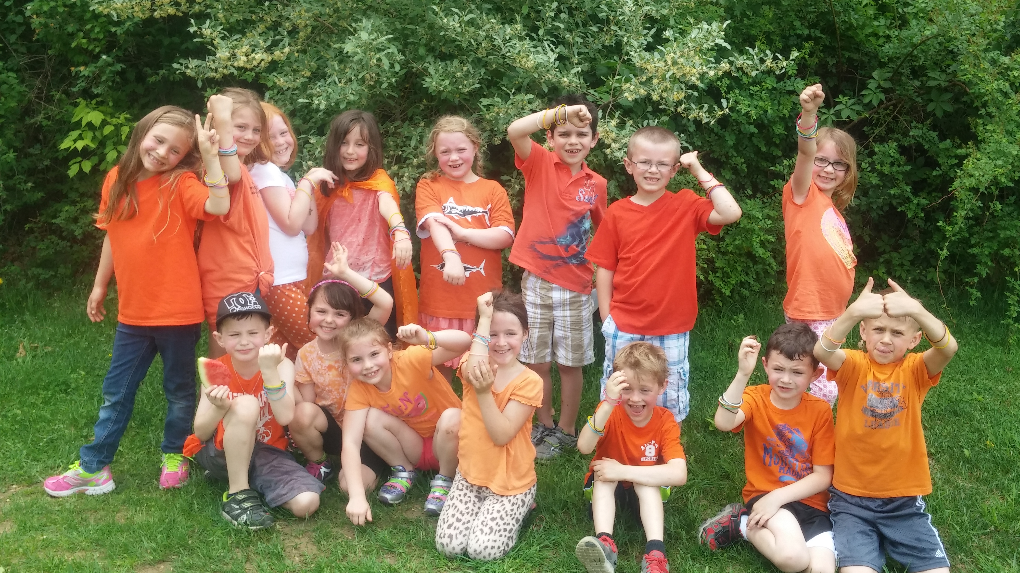

* We had our LAST spelling test of the year on Tuesday! We also began our end of the year math assessment, and sight word assessments. These will continue next week and hopefully finish by Friday.
* We began work on our final draft of our classroom book we wrote together last week! We look forward to presenting it next week at Whole School Meeting!

**Christyn’s First Grade**

**Weekly**

**Newsletter**

May 26th-29th

* **June 4- 1st and 2nd Grade Spring Concert- Swasey Gym**

**at 6:30. 1st and 2nd Graders should arrive at the**

**Swasey Gym by 6:20.**

* **June 5th- We will present at Whole School Meeting @ 8:45am!**
* Next Week’s Star: **Ethan**!