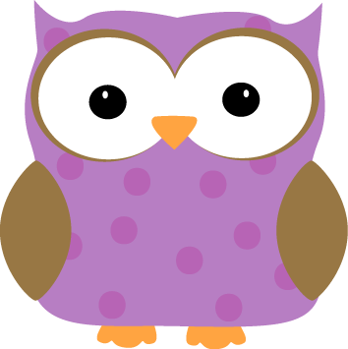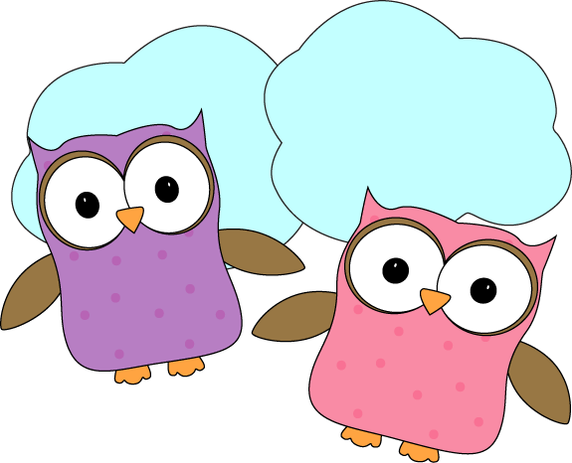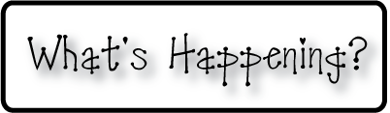man

**Next week-**

* We will continue working on learning time. We will learn about “quarter after” and “quarter of” times.
* We will start learning about a new pattern with reading.
* Starting next week, blue books will be due on Fridays to allow me to bring them home over the weekends to review and correct before they go back out again on Mondays.
* We will continue our reading groups and practicing our sight words.

**-Needed in our class-**

* Watercolor paints

* Hand-held pencil sharpeners (that hold shavings)

* Multicolor card stock- any color

* Empty yogurt containers for painting



**This week-**

* This week we wrote character descriptions of our Big Green Monsters that we painted last week. It’s been so fun getting to learn about who each monster is and what their interests are!
* We worked together to create a poem about our sound project we did last week. Last week after reading The Girl Who Heard Colors, we painted pictures to represent the colors we felt and saw while listening to each musical piece. Our final part of this project was to work together to use adjectives, nouns, and verbs to create a descriptive poem to tell others how we felt while listening to each song, and what we thought of. Check out our amazing work on the bulletin board by the front door!
* We continued working on Magic e words!

**Christyn’s First Grade**

**Weekly**

**Newsletter**

March 23-27th

**March 30- Progress reports go home**

* **Extra clothes could be useful to send in to school as**

**some of the kids are getting wet at recess due to**

**puddles and wet melting snow.**

* Next Week’s Star: **Gabrielle**!