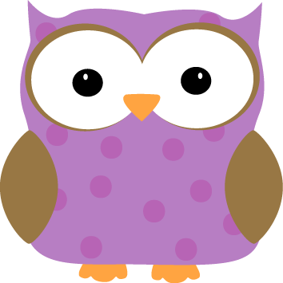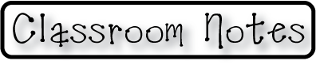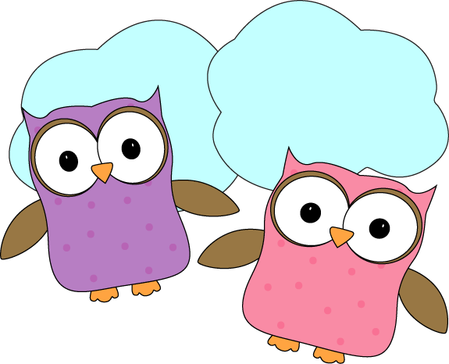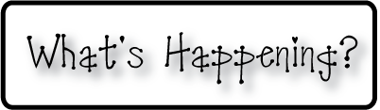

**Next week-**

* We will do a lesson next week with adding extra details to our writing. We will practice new methods in the coming weeks as well.
* This week for a “Sound” lesson, we read a book called The Girl Who Heard Colors. We did a great project where we painted the colors we “saw” while listening to various types of music. Next week we will finish these projects as we describe what we heard and what made us think of those colors.
* We will continue our reading groups and practicing our sight words.

**-Needed in our class-**

* Watercolor paints

* Hand-held pencil sharpeners (that hold shavings)

* Multicolor card stock- any color

* Empty yogurt containers for painting

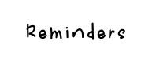

**This week-**

* This week we were able to make it through our last reading assessment! We’ve got some fantastic readers in our class, I’ve been so pleased with the progress that many of our students are making.
* We were introduced to the concept of telling time this week. We have practiced reading a clock to know the times on the hour and seem to feel pretty confident already. Next week we look forward to adding in the half hour times and using our classroom clocks that we made to help us.
* This week we made some fantastic monster drawings/paintings using crayon resist! These art pieces were created by listening to the story Go Away Big Green Monster and drawing what we hear. Next week we will write about our monsters to go along with our art! These will be hung outside of our class for viewing.

**Christyn’s First Grade**

**Weekly**

**Newsletter**

March 16-20th

* **This is the last weekend of the SCS Pizza Kit**

**fundraiser. All order forms and payments need to**

**be turned in on Monday March 23rd. We cannot**

**accept any late order forms.**

* Next Week’s Star: **Ryleigh**!