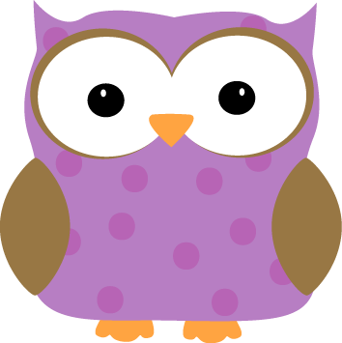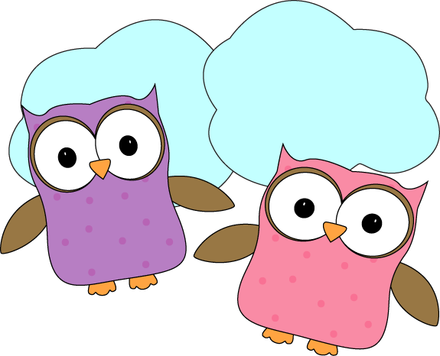

**This week-**

* This week we began our science unit on Light and Sound. We learned that light travels in straight lines and when an object blocks the light a shadow is formed behind that object. We also learned a few new terms in relation to light: transparent- light moves easily through an object, opaque- light is not able to move through an object, and shadow- formed when an object blocks light.
* We began learning about consonant blends this week and have practiced recognizing “st- words”. See if your student is able to find things around the house or in your travels this weekend that also begin with “st-“!
* In Math this week we are continuing to work on math stories as we get better at addition and understanding the numbers that combine to create numbers up to 10, and a few extra challenges to 20!

**Christyn’s First Grade**

**Weekly**

**Newsletter**

January 5-9th (2015!)

**Next week-**

* We will continue to work on Light and Sound and will learn a few new terms.
* We will begin our unit on China and learn about the differences in Chinese culture compared to our own.
* We will continue to work with math stories and build our skills with addition. Next week we will also do our first math fluency check in the form of a timed test to check our addition fluency. Students will be given 3 minutes to complete as many of the 30 addition facts as possible using addition facts up to 10.
* We are going to start slowly getting back into spelling. We will alternate weeks focusing on spelling, and our math fluency in homework assignments. Next week we will get a new list of spelling words for a spelling test the following week.

**-Needed in our class-**

* Multicolor card stock- pastels

* Empty yogurt containers for painting

* Glue sticks

**January 16th- 1/2 day, noon dismissal**

**January 19th- No School- Martin Luther King Day**

* Check out the class website for volunteer opportunities!
* Don’t forget warm jackets, snowpants, boots, gloves/mittens,

and hats **every day**! It’s getting cold and you need them for snow!

* + Indoor shoes and slippers **(with backs please!)** can stay at school
* Next Week’s Star: **Alex**!

