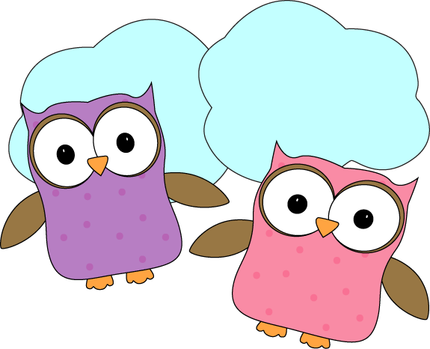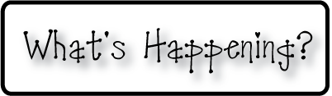



**This week-**

* Do we think we’ve had enough snow days yet?! Due to all of the snow days and my 2 day conference, I am smooshing a few weeks into one newsletter…
* We have been hard at work studying about China and becoming more familiar with the culture. We created Chinese lanterns and decorated them with colorful dragons (a Chinese symbol of power, strength and good luck!). We also learned how to write our names using Chinese characters, and drew them on the sides of our lanterns.
* During the Great Kindness Challenge, we collected a coupon for each challenge we completed. After a short 3 days of challenges, we had earned 408 coupons!
* We have begun writing How-to books, and together are writing how to get ready to play in the snow. Some of the kids are also using their extra work times to create their own stories too!

**Christyn’s First Grade**

**Weekly**

**Newsletter**

January 19- February 6th

**Next week-**

* We will continue to work with our sight words and do more to help us become more fluent when reading and writing those words.
* We will get a new set of spelling words next week for homework and will continue learning about those words in class during our reading groups and literacy blocks.
* **Monday** we will have our next math fluency test to see how we are progressing with our addition fluency. Make sure to practice over the weekend if you haven’t yet this week!
* Mid-year DRA assessments will begin next week, in addition to our mid-year math assessments. We will work over the course of the next 2 weeks on these assessments to ensure that the kids aren’t overloaded and we can get accurate representations of student skills and abilities.

**-Needed in our class-**

* Multicolor card stock- pastels

* Empty yogurt containers for painting

* Glue sticks

**February 20th- Half day, NOON DISMISSAL**

**February 23-27- No School- February Break**

* **Please keep anything Pokemon at home! They are no longer**

**allowed in our class as they have become a distraction at inappropriate times and are taking away from our learning. Anything Pokemon will be taken and given back to parents. Thanks!**

* Next Week’s Star: **Richard**!