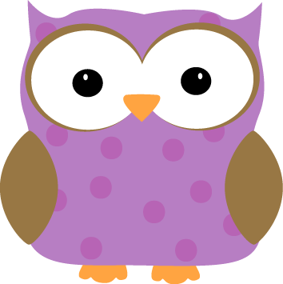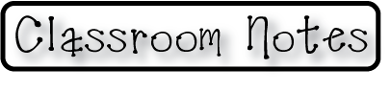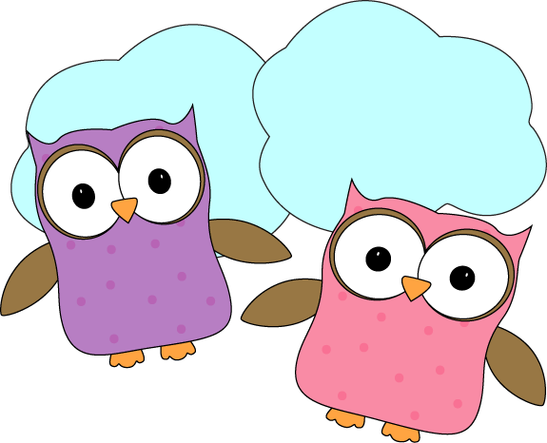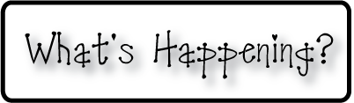

**This week-**

* This week we continued our unit on Light and Sound. We learned about how light reflects and refracts and did some experiments to help show us what the effects of using water to show refraction are! We looked at a pencil in water and saw the pencil bend, and seem to cut in half, and then we looked at an arrow in water and saw it flip and point in the other direction! Ask your kids about some of the other experiments that we learned about that can be done at home to play with reflection and refraction ☺
* We continued to work with math stories, and completed our first timed test. We will continue to do these fluency tests every other week, and alternate them with our spelling tests.

**Christyn’s First Grade**

**Weekly**

**Newsletter**

January 12-16th

**Next week-**

* We will take a break from light and sound to work on beginning our social studies unit on China!
* We will move from addition math stories into working on subtraction math stories.
* We will complete our first spelling test of the New Year. We will alternate weeks focusing on spelling, and our math fluency in homework assignments. Next week we will get another math fluency test to practice at home for our fluency test the following week.
* Don’t forget! **NO SCHOOL MONDAY!**

**-Needed in our class-**

* Multicolor card stock- pastels

* Empty yogurt containers for painting

* Glue sticks

**January 19th- No School- Martin Luther King Day**

* Check out the class website for volunteer opportunities!
* Don’t forget warm jackets, snowpants, boots, gloves/mittens,

and hats **every day**! It’s getting cold and you need them for snow!

* + Indoor shoes and slippers **(with backs please!)** can stay at school
* Next Week’s Star: **Clara**!

