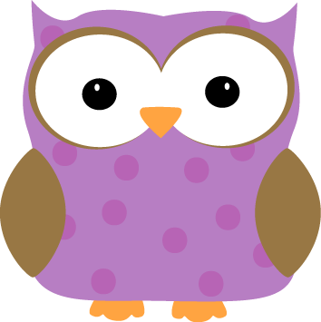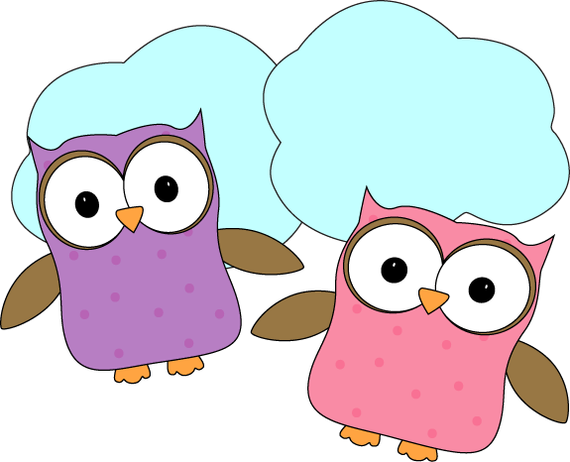

**Christyn’s First Grade**

**Weekly**

**Newsletter**

December 8th-12th

**Next week-**

* We will share our Personal Narrative stories with the class each day. The kids worked so hard on them and should be proud!
* We’ll finish our Pookala artwork, and Banyan trees early next week, and get to study some of the celebrations in Indian culture. While we’re studying the celebrations we will learn about how elephants are used in celebrations and decorate our own elephants just like in India!
* We’ll finish up our geometry unit in time for the end of the month and winter break!
* Next week we will each get our own sight word index cards to keep all of the “Words I know”, “Words I’m working on”, and “Words I’ll Learn” together. This will help us to keep track of exactly which words we should be studying at home and in reader’s workshop groups to become better readers and then better writers!

**-Needed in our class-**

* Multicolor card stock- pastels

* Empty yogurt containers for painting

**December 19- Half Day- Noon Dismissal**  
**December 24-January 2- Holiday Break- No School**

* Check out the class website for volunteer opportunities!
* Don’t forget warm jackets, snowpants, boots, gloves/mittens,

and hats **every day**! It’s getting cold and you need them for snow!

* + Indoor shoes and slippers **(with backs please!)** can stay at school
* Next Week’s Star: **Cooper**!

**This week-**

* We are almost finished with our Pookala Indian artwork! We’ve gotten a lot of work done on them and are happy with the results!
* We learned this week about Banyan trees, and how important they are to the Indian culture. We began a beautiful piece of art to celebrate the beautiful Banyan trees, and learned a yoga pose called the “Banyan Tree Pose”. If you have a free wall and couple of minutes, ask your student to show you how our tree branches can become roots just like the Banyan tree!
* We’ve continued to work with geometry and are discovering more ways that shapes can be put together to create different shapes. We’re playing “Build a Hexagon” with each other and having a lot of fun manipulating shapes!

