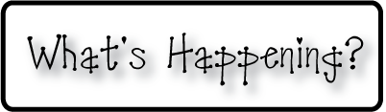man

**Next week-**

* We will continue our Japan unit, and learning about our final country in Asia for the year. Each day we will create a new origami art piece to take home, and read some more short stories from Japan.
* We will continue our unit with place value and add 100s to the 10s, and 1s we discussed this week.
* We will be continuing our reading groups and improving our reading skills.
* We will have another spelling test on Monday.
* We will not have a homework packet next week, however our blue books **WILL** go home with a new word family to be returned the Friday before vacation.

**-Needed in our class-**

* ***Tissues***

* Multicolor card stock- any color

* Black construction paper (standard sized and large)



**This week-**

* This week we began our unit on opinion writing. We discussed how each one of us is different and will have different ideas about certain things. We talked about how this doesn’t make one person right and another wrong, but just simply means that our opinions are different. We read Don’t Let the Pigeon Drive The Bus! by Mo Willems and wrote an opinion piece about if we would or would not let the pigeon drive the bus, and why. To connect this unit with math, we did survey questions to refresh ourselves with how to fill in and read surveys, and also to give us a tool for further discussion and topics for opinion writing.
* We are off to a great start with our place value work in math as well! We learned about rods and cubes to represent 10s and 1s, and looked at how rods and cubes can be combined to make numbers. We’re geniuses!

**Christyn’s First Grade**

**Weekly**

**Newsletter**

April 13th-17th

**April 27-May 1- April Vacation- NO SCHOOL**

**The 1st and 2nd grade Spring Concert date is currently**

**set for June 4th. A final notice of this will be**

**provided at a later date to confirm.**

* Next Week’s Star: **Faith**!